Osman Khan

Gustavo Cisneros

CECS 323

May 5, 2020

Queries and Output

1.) The list of all airlines for a given airport.

SELECT AirlineName, AFAAABBREV, DFAAABBREV FROM Airport

INNER JOIN Flight ON FAAABBRV = AFAAABBREV OR FAAABBRV = DFAAABBREV

WHERE FAAABBRV = 'ORD';

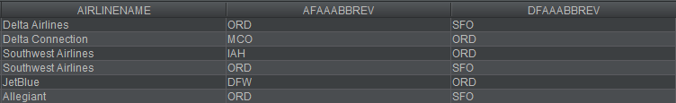

2.) The list of all flights for a given airline.

A.) ORDER BY Departure Aiport

SELECT FlightNumber, DFAAABBREV AS DepartureAirport, AFAAabbrev AS ArrivalAirport, AirlineName,

DepartureTime, ArrivalTime, TailName AS Plane

FROM Flight

WHERE AirlineName = 'JetBlue'

ORDER BY DepartureAirport;

B.) ORDER BY Arrival Aiport

SELECT FlightNumber, DFAAABBREV AS DepartureAirport, AFAAabbrev AS ArrivalAirport, AirlineName,

DepartureTime, ArrivalTime, TailName AS Plane

FROM Flight

WHERE AirlineName = 'JetBlue'

ORDER BY ArrivalAirport;

C.) ORDER BY Shortest Flight

SELECT FlightNumber, DFAAABBREV AS DepartureAirport, AFAAabbrev AS ArrivalAirport, AirlineName,

DepartureTime, ArrivalTime, {fn TIMESTAMPDIFF(SQL_TSI_HOUR, DepartureTime, ArrivalTime) } AS "Flight Length in Hours"

FROM Flight

WHERE AirlineName = 'JetBlue'

ORDER BY "Flight Length in Hours";

D.) ORDER BY Longest Flight

SELECT FlightNumber, DFAAABBREV AS DepartureAirport, AFAAabbrev AS ArrivalAirport, AirlineName,

DepartureTime, ArrivalTime, {fn TIMESTAMPDIFF(SQL_TSI_HOUR, DepartureTime, ArrivalTime) } AS "FlightLength Hours"

FROM Flight

WHERE AirlineName = 'JetBlue'

ORDER BY "FlightLength Hours" DESC;

3.) Flights that charge for extras (water, etc.)

SELECT FlightNumber, DFAAABBREV AS DepartureAirport, AFAAabbrev AS ArrivalAirport, AirlineName,

ServiceType, Cost

FROM FLIGHT

NATURAL JOIN Service

WHERE Cost != 0

ORDER BY Cost;

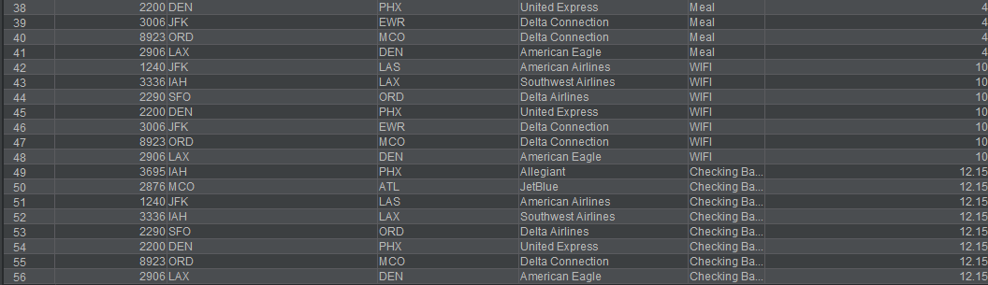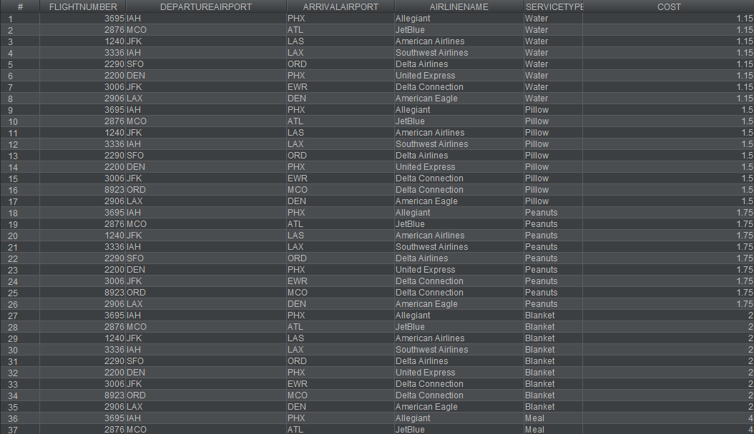

4.) The crew roster for each flight for each airline

SELECT DISTINCT FlightCrewName, FlightNumber, AirlineName, Crewmember.*

FROM FlightInstance

NATURAL JOIN Flight

NATURAL JOIN CrewMember;

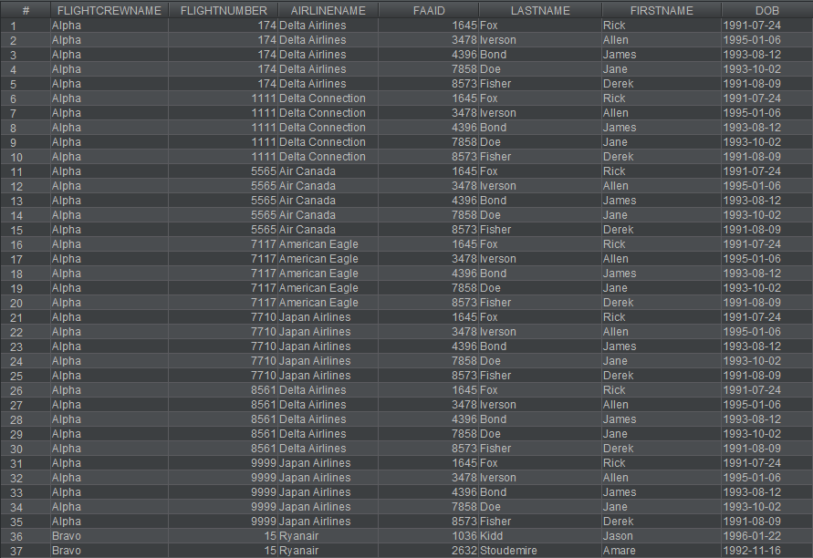

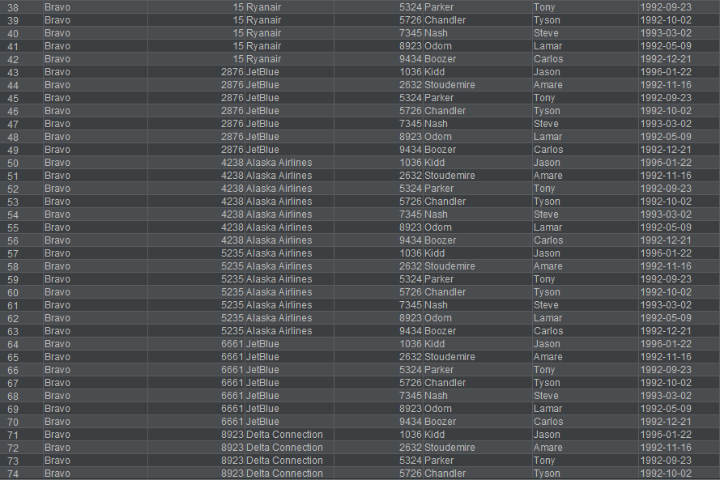

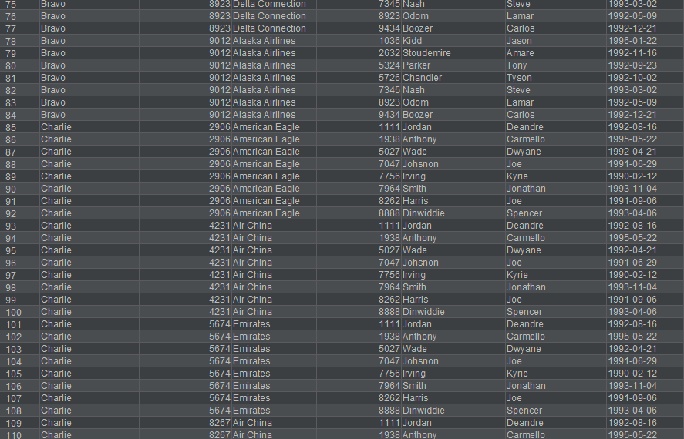

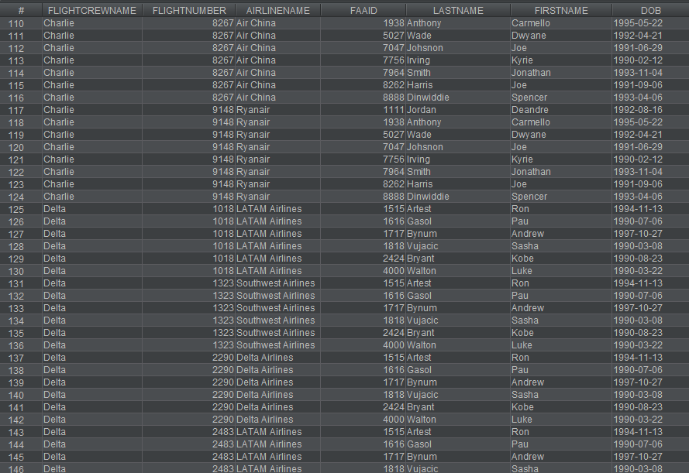

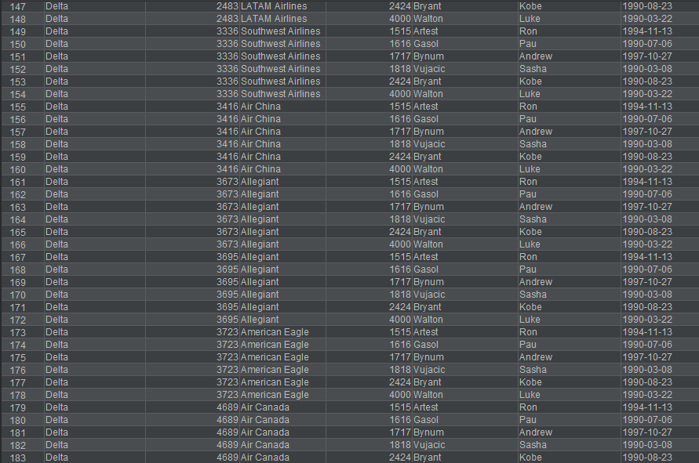

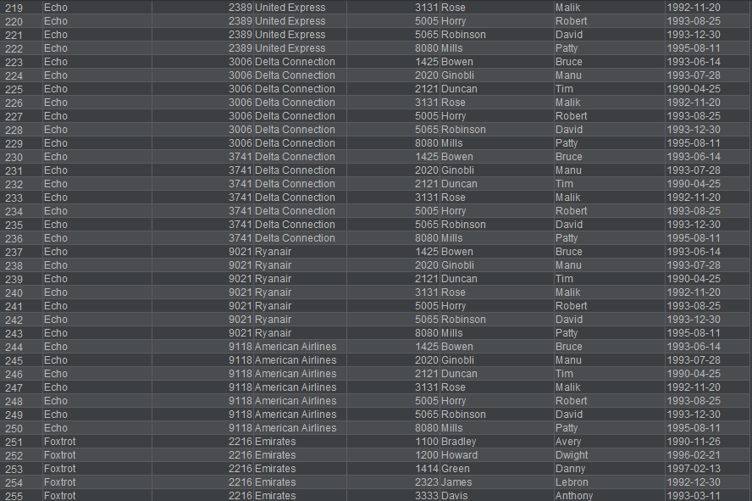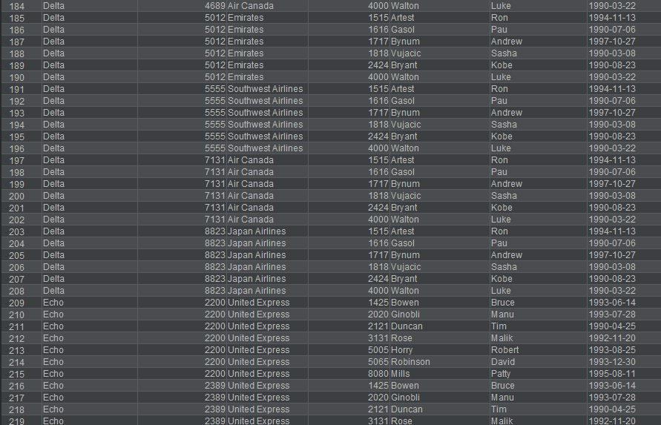

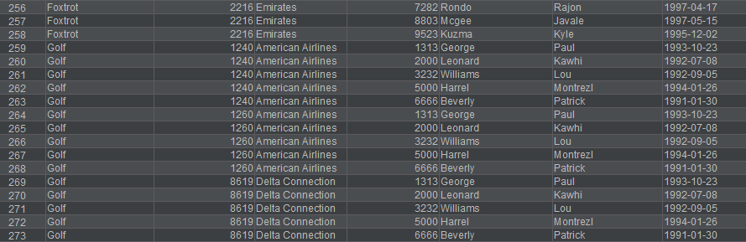

5.) The trips that are available if you make one stop over

SELECT

f1.AirlineName,

f1.TailName,

F1.Dfaaabbrev AS "Departing from",

f1.Afaaabbrev AS "Arriving to",

F2.AFAAABBREV AS "Next Possible Stop Location",

F2.TailName AS "FlightNumber to Take",

F2.DepartureTime AS "Departing Time"

FROM

Flight f1

INNER JOIN

flight F2 ON F1.Afaaabbrev = F2.DFAAABBREV

AND F1.AirlineName = F2.AIRLINENAME

ORDER BY F1.AIRLINENAME;

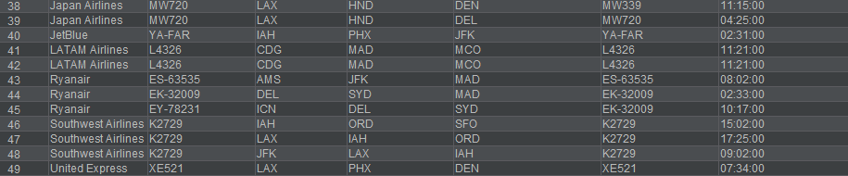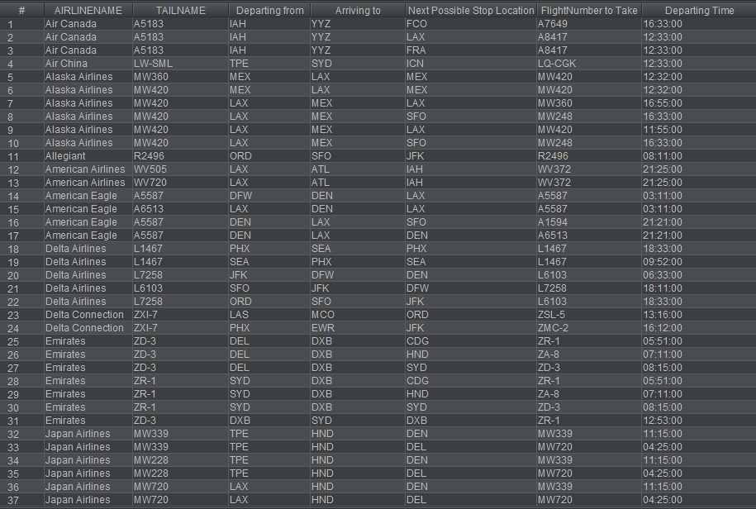

6.) Management Reports of Mifly Information

-A.) Arriving flights per city

SELECT AirportLocation, COUNT(FAAABBRV) AS "Arriving Flights"

FROM Airport

NATURAL JOIN Flight

WHERE FAAABBRV = AFAAABBREV

GROUP BY AirportLocation

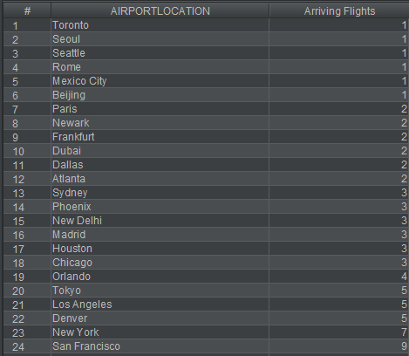ORDER BY "Arriving Flights";

B.) Departing flights per city

SELECT AirportLocation, COUNT(FAAABBRV) AS "Departing Flights"

FROM Airport

NATURAL JOIN Flight

WHERE FAAABBRV = DFAAABBREV

GROUP BY AirportLocation

ORDER BY "Departing Flights";

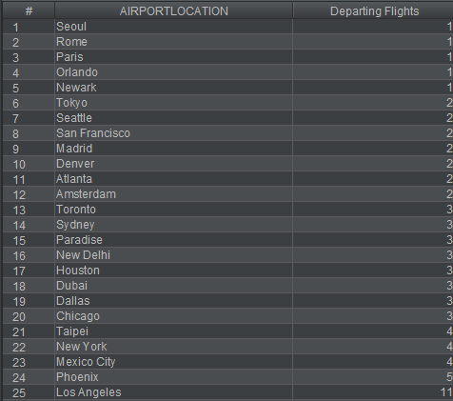

C.) List of airlines in each service category

SELECT AirlineName, Region

FROM Airline;

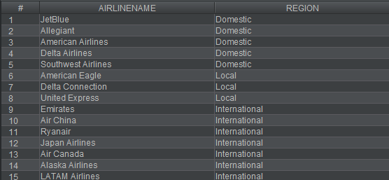

D.) Crews that fly multiple flights in a single day

SELECT FlightCrewName, FlightDate, COUNT(FlightDate) AS "Total Flights"

FROM FlightCrew

NATURAL JOIN FlightInstance

GROUP BY FlightCrewName, FlightDate

HAVING COUNT(FlightDate) > 1;

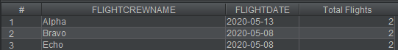

7.) A list of all incident reports by flight

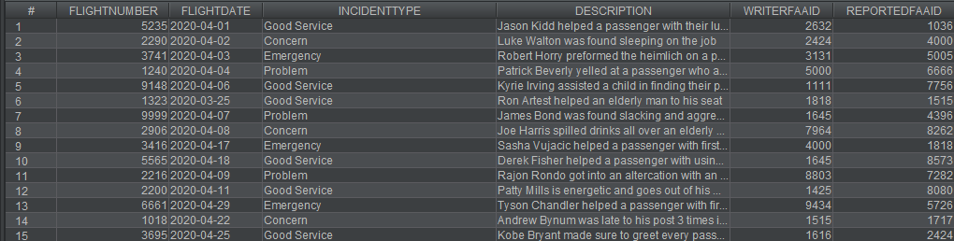SELECT * FROM IncidentReport;

8.) Flights departing in 3 days

SELECT * FROM FLIGHTINSTANCE

WHERE FlightDate = CAST({fn TIMESTAMPADD (SQL_TSI_DAY, 3, CURRENT_TIMESTAMP) } AS DATE);

9.) All flights that arrived in the busiest airport in the last week

SELECT * FROM FlightInstance

NATURAL JOIN Flight

WHERE AFAAabbrev IN

(SELECT AFAAabbrev

FROM FlightInstance

NATURAL JOIN Flight

WHERE FlightDate

BETWEEN CAST({fn TIMESTAMPADD(SQL_TSI_DAY, -7, CURRENT_TIMESTAMP)} AS DATE)

AND CAST({fn TIMESTAMPADD(SQL_TSI_DAY, 1, CURRENT_TIMESTAMP)} AS DATE)

GROUP BY AFAAabbrev

ORDER BY COUNT(AFAAabbrev) DESC

FETCH FIRST ROW ONLY)

AND FlightDate

BETWEEN CAST({fn TIMESTAMPADD(SQL_TSI_DAY, -7, CURRENT_TIMESTAMP)} AS DATE)

AND CAST({fn TIMESTAMPADD(SQL_TSI_DAY, 1, CURRENT_TIMESTAMP)} AS DATE);



10.) Flights that departed more than 30 minutes late.

SELECT FlightNumber, AirlineName, DepartureTime, ActualDepartureTime

FROM FLIGHT

NATURAL JOIN FLIGHTINSTANCE

WHERE {fn TIMESTAMPDIFF(SQL_TSI_MINUTE, DepartureTime, ActualDepartureTime)} > 30;

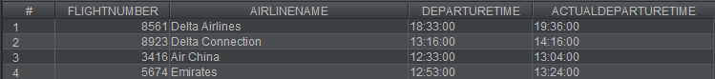

11.) Business Rules

-- A.) This is to display our first business rule to show that a meal should be free for where the condition was met

SELECT FlightNumber, Region, ServiceType, Cost, {fn TIMESTAMPDIFF(SQL_TSI_HOUR, ActualDepartureTime, ActualArrivalTime)} AS "Length of flight"

FROM Service

NATURAL JOIN FlightInstance

NATURAL JOIN Flight

NATURAL JOIN Airline

WHERE ServiceType = 'Meal'

AND Region = 'Domestic'

ORDER BY "Length of flight";

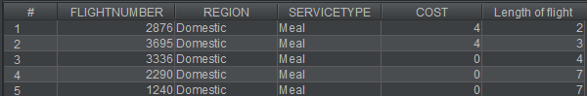

B.) This is to display our third business rule to show that water should be free for where the condition was met

SELECT FlightNumber, Region, ServiceType, Cost, {fn TIMESTAMPDIFF(SQL_TSI_HOUR, DepartureTime, ActualDepartureTime)} AS "Delay in hours"

FROM Service

NATURAL JOIN FlightInstance

NATURAL JOIN Flight

NATURAL JOIN Airline

WHERE ServiceType = 'Water'

AND Region = 'Local'

ORDER BY "Deleay in hours";

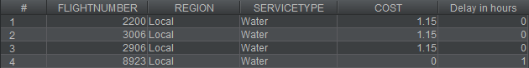

C.) This is to display our second business rule to show that WIFI should be free for where the condition is met

SELECT FlightNumber, Region, ServiceType, Cost, {fn TIMESTAMPDIFF(SQL_TSI_HOUR, ActualDepartureTime, ActualArrivalTime)} AS "Length of flight"

FROM Service

NATURAL JOIN FlightInstance

NATURAL JOIN Flight

NATURAL JOIN Airline

WHERE ServiceType = 'WIFI'

AND Region = 'Domestic'

ORDER BY "Length of flight";

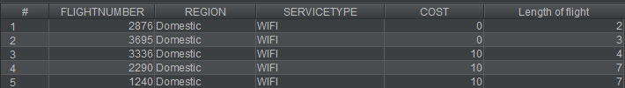

D.) This is to display our fourth business rule to show that checking bags should be free for where the condition is met

SELECT FlightNumber, Region, ServiceType, Cost, {fn TIMESTAMPDIFF(SQL_TSI_HOUR, ActualDepartureTime, ActualArrivalTime)} AS "Length of flight"

FROM Service

NATURAL JOIN FlightInstance

NATURAL JOIN Flight

NATURAL JOIN Airline

WHERE ServiceType = 'Checking Bags'

AND Region = 'Local'

ORDER BY "Length of flight";

